Project title:

Amazon.in (Clone of the E-commerce Website)

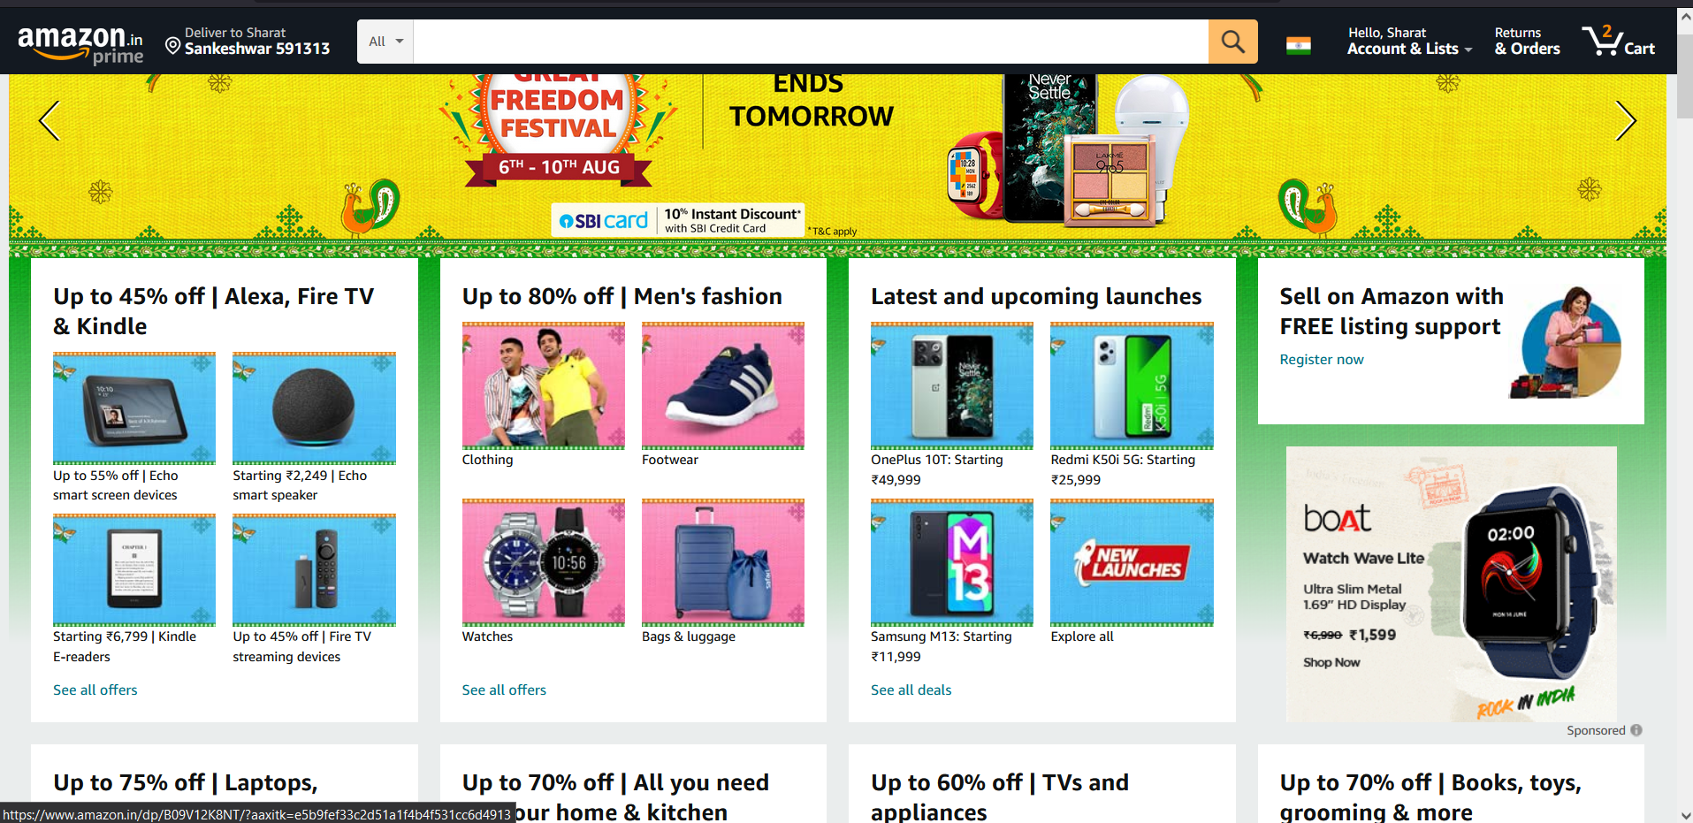

Overview:

Amazon is an American e-commerce multinational company started in 1994. It’s an e-commerce website which is expanded into a multitude of product categories such as Electronics, Fashion and multiple other accessories. And this website focuses on the region specific to India.

Pages:

* Sign in/Sign Up
* Homepage
* Product details
* Payment Gateway

> Sign in/Sign Up :

1. Sign-in with email or phone number
2. Sign up with Create your Amazon account

> Homepage:

1. Logo
2. Delivery Location
3. Search Bar
4. Categories details
5. Side-navigation-bar with filters
6. Orders
7. Account and Lists
8. Cart
9. Image slider with left and right arrows
10. Deals and Offers
11. Trending deals
12. Footer with - about, social media, other links

> Product Details:

1. Description of the product in detail
2. At least more than 1 image with different angles
3. Price
4. Payment Details
5. Buttons(Add to cart and Buy Now)

> Payment Gateway:

1. Address Selection
2. Payment using - Cards, UPI, Amazon Pay, COD